North County Food Bank
Food Center Hours:
Monday - Friday 7:00 a.m. – 11:00 a.m.

2021 Holiday & Inventory Schedule
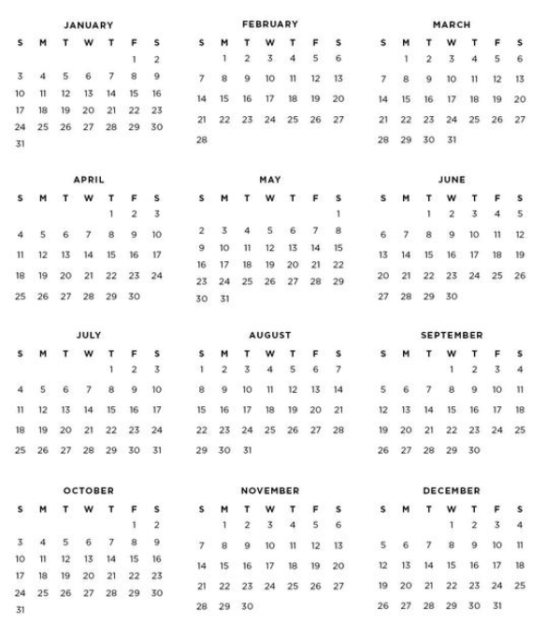
The Food Center
will be closed:

Jan 1 New Year’s Day
Jan 18 MLK Jr Day
Jan 29 Inventory
Jan 30 Inventory
Feb 15 President’s Day
Mar 31 Cesar Chavez Day
Apr 29 Inventory
Apr 30 Inventory
May 31 Memorial Day
Jun 29 Inventory
Jun 30 Inventory
July 5 Independence Day
Sep 6 Labor Day
Sep 29 Inventory
Sep 30 Inventory
Oct 11 Native American Day
Nov 11 Veteran’s Day
Nov 25 Thanksgiving Day
Nov 26 Day after Thanksgiving
Dec 23 Christmas Eve (observed)
Dec 24 Christmas Eve
Dec 31 New Year’s Eve

Please plan shopping for
your food programs accordingly.
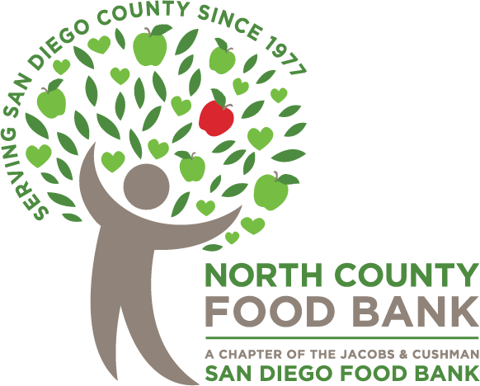
Closed for Inventory
Closed for Holiday
1445 Engineer St., Ste 110, Vista, CA 92081
Questions? Contact Wendy Starling at wstarling@sandiegofoodbank.org

